Ms. Iman

Last Name A-F

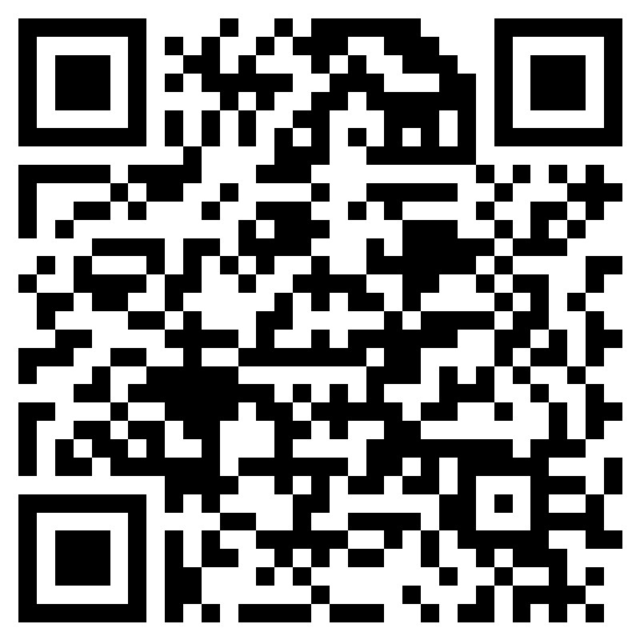



Mrs. Barber

Last Names G-O

Ms. Nickerson

Last Names P-Z

Mrs. Eakins

AICE Counselor

