Name: _______________________________________________________________
The Glass Castle by Jeannette Walls
Data Sheet
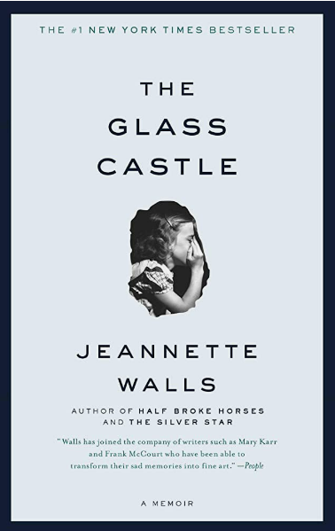
Directions: Fill in the sections of this data sheet completely while reading the memoir.

General Information  Title:  Author:  Data of publication:  Genre: | Biographical Information about the Author
Historical Context(s) of the Novel | Characteristics of the Author’s Style

Plot Summary
Write at least one paragraph for each part of the book.
Part One

Part Two

Part Three

Part Four

Part Five

Author’s Tone
What is the author’s attitude toward the text?
Words to describe the tone | Examples from the text to support the tone

Setting
Identify where and when the novel is set.
Setting(s) | Significance of opening and closing scenes

Characters
Identify the significant characters in the novel.
Name | Role in the Story | Significance | Adjectives

Memorable Quotes
Identify important quotes from the novel.
Quote (page #) | Significance of each quote

Symbols
What are the important symbols in the novel?
Important Symbols | Significance of the Symbols

Possible Themes
Identify at least three (3) and support your inferences with evidence from the novel.
Theme 1:

Theme 2:

Theme 3:

