Class: AICE General Paper 11th Grade

“This course is an AICE, AP, IB, or DE course designed to earn college credit as well as meet high school graduation requirements. As such, materials and discussions for this course may reflect topics not typically included in SJCSD courses. Due to the dual credit nature of this course, content and materials used in this course are not able to be modified to accommodate variations in student age and/or maturity."

To prepare for the rigor of this course, we recommend that you choose 2 selections from the list below to read over the summer. The AICE curriculum challenges students to read and think at a higher level and produce quality work. Be prepared to discuss themes, point of view, and character development from the novels you choose. We will be completing a collaborative activity during the first weeks of school that will require you share what you have learned.

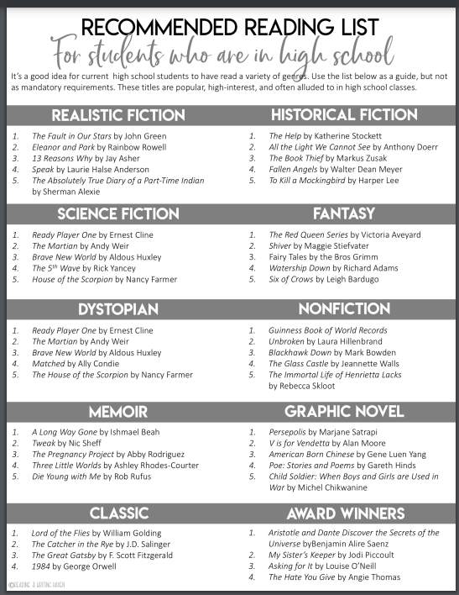

For questions over the summer, contact:

Jessica Alexander@Jessica.Alexander@stjohns.k12.fl.us

