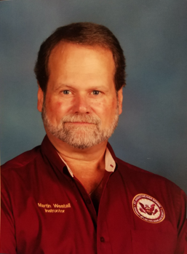
Martin Westall is an Instructor at St. Augustine High School in the Academy of Law and Homeland Security. He is a Veteran of local Law Enforcement, having served with the St. Johns County Sheriff’s Office, Clay County Sheriff’s Office, Jacksonville County Sheriff’s Office, and City of Green Cove Springs Police Department. He brings his experience in Law Enforcement, and knowledge of Florida Laws, as well as diversity and cultural changes from those departments to the classroom. He believes that while Patrol is the backbone of any department, teaching this environment to high school students is vital to their future vocational lives after graduation. Mr. Westall has three grown children and 1 grandson. His hobbies include horseback riding (owned a farm), going to the shooting range, riding on the beach and trails in a Jeep, mountain trips, and photography. He enjoys playing Santa Claus during Christmas season. He inspires students with two favorite quotes: “We are constantly learning, even at my age!”, and “The FBI calls that a clue!”

