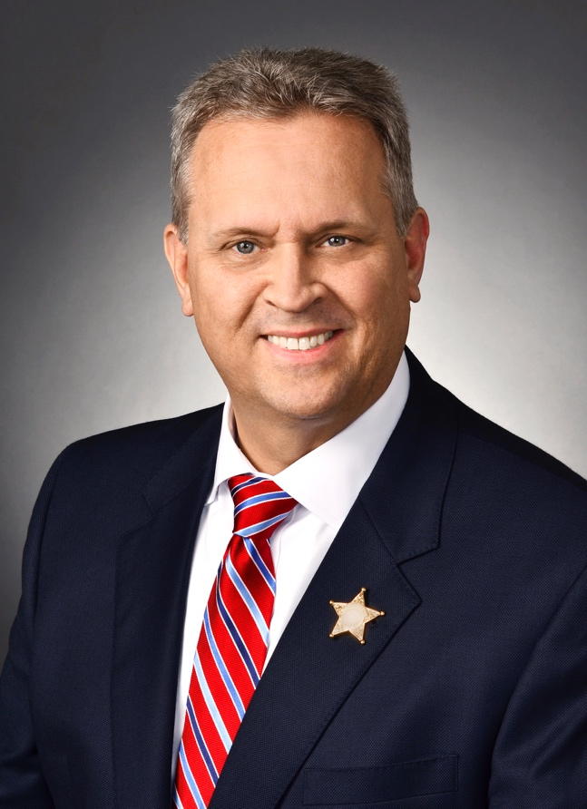
Harold Rutledge comes to St. Augustine High School with a combination of 37 years’ experience in criminal justice and education. Harold, a retired Lieutenant, began his career at the age of twenty two as a correctional officer. After several months, he transferred to the patrol division. During his career, Lt. Rutledge worked as a watch commander, school resource officer, hostage negotiator, field training officer, and a traffic homicide investigator, to name a few. He was a certified instructor in hostage negotiations, police radar operator, pepper spray, defensive tactics, firearms, and taught at the First Coast Technical College and the St. Johns River Police Academy.
He began his teaching career as the school resource officer at Clay High School in Green Cove Springs. He was asked to create the criminal justice program for the Academy of Law and Emergency Services and held the first class in 2003. That first class had only 12 students. Lt. Rutledge retired in 2015 from teaching with a robust program of nearly 400 students. In fact, his program was only the second criminal justice program in the nation to receive the prestigious Model Status from the National Career Academy Coalition.
During this same time period, Mr. Rutledge was elected as a County Commissioner for Clay County’s District Five. He served as the chairman of the Parks and Recreation Committee, the chairman of the Budget and Finance Committee and Chairman of the Board of County Commissioners. During his time as a commissioner, he reduced property taxes by more than 20 percent while, funded needed road projects, a new Emergency Operations Center, and preserved the 150 acre Camp Chowenwaw Girl Scout camp as a Florida Forever park so generations to come can enjoy Clay County’s hidden treasure.
Lt. Rutledge holds advanced degrees in Criminal Justice, an Associate in Arts Degree from St. Johns River State College, a Bachelor’s Degree in Psychology from the University of North Florida, and a Master’s Degree in Business from Ashford University. Education is something he strongly believes in and is one of a few things someone cannot take from you.
Harold and his wife have been married for more than 25 years and have four children. Three of his four children have either graduated or are currently attending the criminal justice program he built at Clay High School.
After retirement, Lt. Rutledge was asked to help start the criminal justice program at St. Augustine High School with the Academy of Law and Homeland Security. After the program got off to a rocky start, Harold was asked to join St. Augustine High School and teach the program. He left retirement and the golf course and has taken the program from 60 to nearly 200 students in just three years. This second program he has built offers the students a chance to earn 6 high school credit towards graduation, leave high school with the Police Service Aide (P.S.A.) certification, Florida Class D security guard license, and the 911 Telecommunicator license from the Florida Department of Health. These certifications and licenses allow a high school student to graduate and enter the workforce full or part-time.

