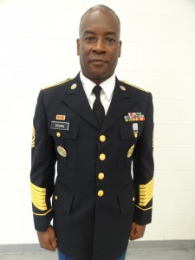
First Sergeant Carlton Dale Brown was born in West Palm beach Florida and raised in suburban Atlanta Georgia. During his childhood he spent many long hours and days working his grandmother’s farm land. Working was part of his everyday life and yet he found time to study and finish school. First Sergeant Brown attended Lee County High School where he played basketball and ran track. He graduated in 1978 and went on to attend Atlanta Area Technical College. After a few years at the technical college, First Sergeant Brown decided to join the United States Army where he served as a logistics specialist, military intelligence sergeant, drill sergeant, and recruiting company First Sergeant. After 20 years of military service First Sergeant concluded his time in the army and retired in 2000. In 2001, First Sergeant Brown found employment as a JROTC instructor, Football coach, Basketball coach, and head track coach here at St. Augustine High School where he still serves today. First Sergeant Brown has obtained his bachelor’s degree from the University of Phoenix and is in the process of completing his master’s at the university.
Army Instructor: (Ret.) 1SG Carlton D. Brown

