

**Dual Enrollment Online Application Instructions**

**Please use the steps below to assist you with completing the online dual enrollment application. If you experience any issues, please feel free to call the Dual Enrollment Office at (386) 312-4136.**

**Step 1: Go to the following link to reach the dual enrollment online application:**

<https://bit.ly/2APhdpC>

**Step 2: Select “First time user account creation”**

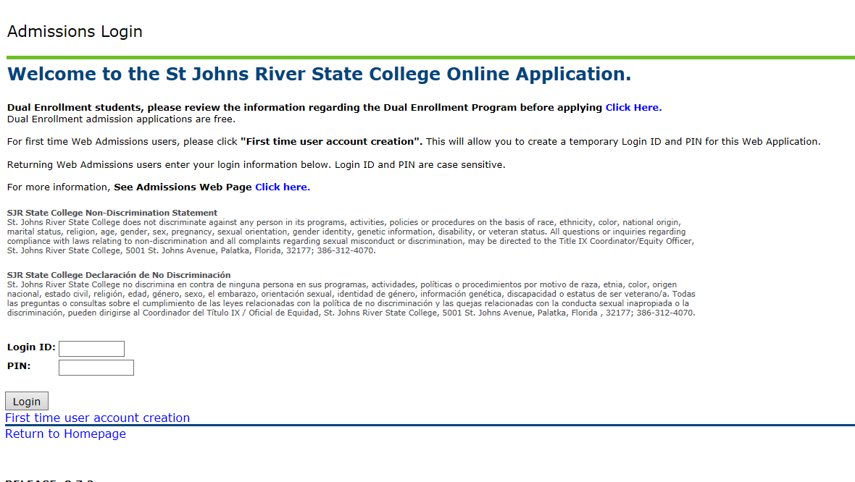

**Step 3: Set up your Admissions Login information**

**\*Read the directions for how to setup your user log-in and pin. Once setup, select “Login”. Please remember your log-in credentials. You will need this again if you save your application and need to go back to work on it at a later time.**

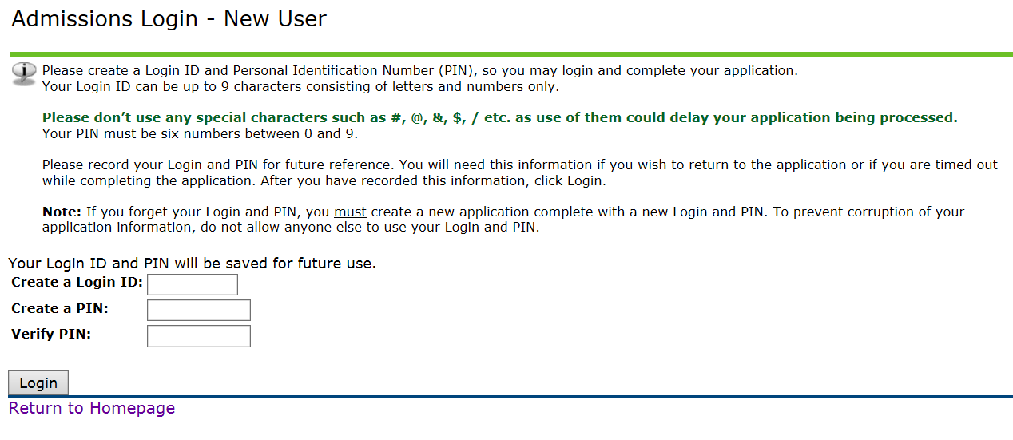

**Step 4: Begin application by selecting Admission Term.**

**\* It is VERY important student’s select the term they will be starting. If they do not select the appropriate term, they will need to do another application.**

**\*Once you have selected your Admission Term and put your First and Last Name, select “Fill Out Application.**

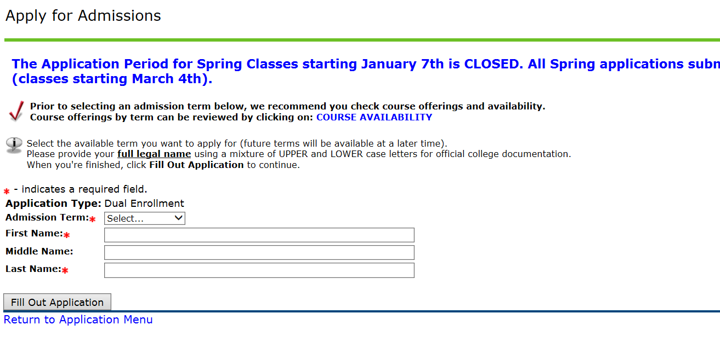

**Step 5: Fill out all sections of the applications listed below.**

**\*You can work on some sections and finish your application later. Make sure to save after each section before hitting “Finish Later”. The application is fairly easy to complete in one sitting.**

**\*Once you have completed all sections, please select “Application is Complete”.**

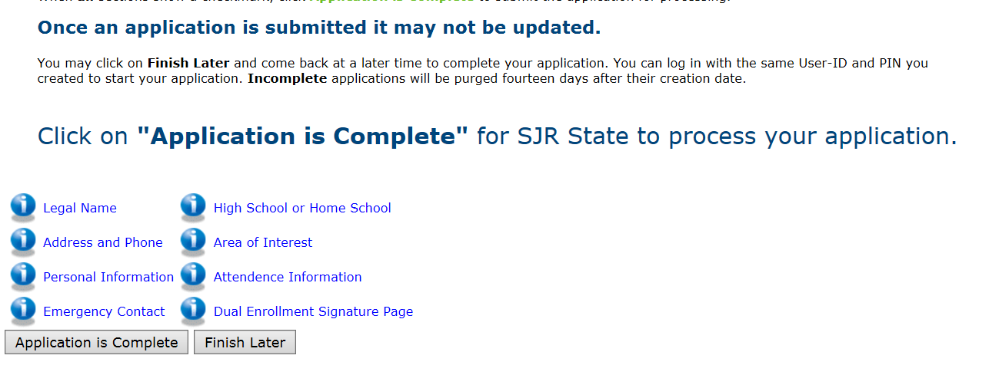

**Step 6: Students should be prompted to print and complete a consent form.**

**\*Student will receive their X numbers right away. Please make sure to keep this information.**

**\*While this is the last step to the online application, students should follow the remaining steps listed:**

**1. Print the Dual Enrollment Consent Form. If the consent form does not pop up after you have completed the application, it is also attached to the acceptance email, and you can print it from there.**

**2. After completed, return the Consent Form and your placement test scores (ACT/SAT/PERT) and any IB/AICE/AP score you want credit for, to your high school guidance counselor. In St. Johns County, collegiate high school students are responsible for their testing. In Clay and Putnam Counties, the collegiate high school students will be signed up for specific test dates.**

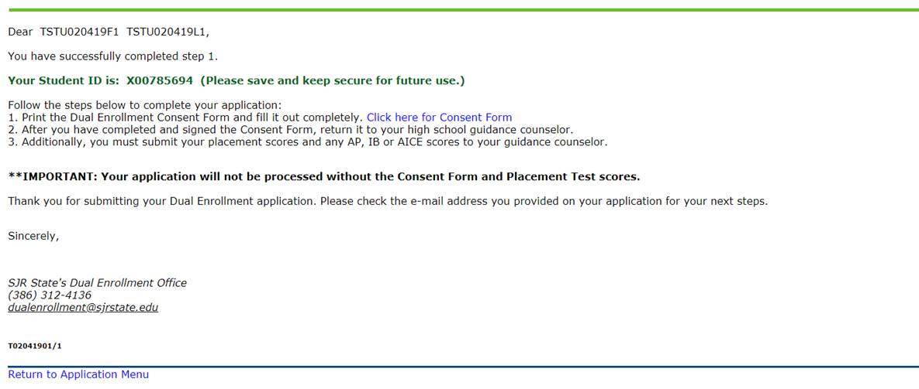

**Trouble Shooting**

**Some students have received the below error message after completing step 2 (setting up user log-in). If this happens, the student should select the link in step 1 again, log-in with the credentials they just created, and should be able to proceed.**

