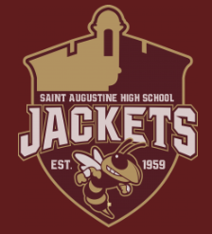

The Cambridge AICE Program at St. Augustine High School
AICE Booster Club Meeting
Minutes for: September 21, 2022
Discussions:
- Introductions to AICE Booster Club and members new and old

- AICE Booster club provides:
  - Funds to supplement (or cover completely) the fee for students to attend a college campus tour (tour dates/times and charter bus transportation organized by AICE Advisory Board each year when permitted) to make them affordable for all students.
  - An account for teachers to use at the UPS store when they need copies, posters, etc. ($100)
  - AICE Student Scholarship(s) every year for AICE Seniors.
  - Provide extra supplies to teachers when needed.
  - Provide supplies needed to make running AICE Exams more manageable and comfortable for all students (like cases of water available for all students during exams, pencils and pens printed especially for the AICE Program at SAHS).
  - Coordinate fund raising and volunteer events with the AICE Advisory Board, providing supplies, extra help, etc.
  - Supply food and drink for AICE events like AICE Advisory Board weekly meetings, AICE Game Day, AICE Induction Ceremony.
  - Purchase Teacher appreciation gifts at the holidays and at the end of the school year.
  - Fund AICE T-shirts, hoodies, Polo Shirts, magnets, clings to help promote the AICE Program.
  - Organize and manage the Annual AICE Silent Auction to raise funds for ALL of the above.

- AICE Exams
  - 2 Sessions – “November and June”
    - Retakes scheduled for October 3rd – Nov. 4th. Approximately 30 students
    - April/June testing – Approximately 800 students
  - Water supplied for examinations supplied by Boosters
    - Sibylle to pick up water for students (Costco?) – water to be delivered to 1st Coast Tech exam location

- Cambridge AICE Parent Night - Tuesday, September 27, 2022, 6:00 p.m. – 7:30 p.m. - St. Augustine High School Auditorium
  - Information to be covered includes:
    - AICE Program Requirements vs. AICE Diploma Award Requirements
    - “Typical” AICE Course Progression – all grade levels
    - AICE Exam Information
    - Tips for Success in the AICE Program
    - College Credit/College Applications/SAT & ACT
    - AICE communications
  - Items for sale/donation Tuesday night
    - T-shirts/clothing items (Michael volunteered to inventory)
      - More shirts are needed – orders in the past were from Sports Corner and 4 Imprints
    - Cookies from cafeteria to be sold (Dena to arrange) $1
    - Bottled water - $1 donation
    - Students may not handle money
    - Sibylle to use Venmo
    - Cynthia to bring cash for change
- Induction Ceremony for 11th graders
  - Discussion to move to January from November
  - Volunteers needed
    - Student – may earn volunteer hours – must wear Cambridge Polo
    - Parent
    - Teacher turnover discussed – new teachers to program
      - Allow new staff to pick from prior years supplies (Dena)

- PSAT – October
  - PSAT for 10th graders free and offered by district
  - PSAT for 11th graders encouraged (Merrit Scholarships offered)
    - How to encourage more 11th graders to take test discussed
      - Emails to students and parents
      - Text to parents
      - QR codes posted about school & stadium
        - Supply information for Ralph I. SAT program, Kahn Academy, other web links

- Next Meeting at DOS October 19th at 3:30
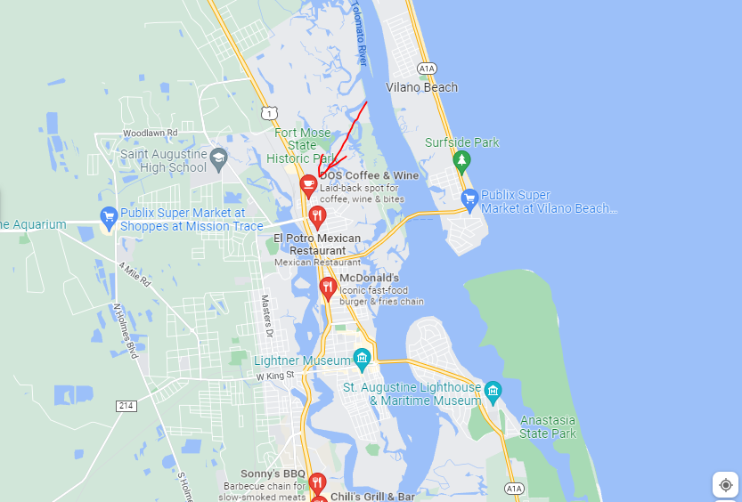
- Christmas Gifts for teachers
- Paper for teachers
- Treat/foods by Student Advisory Board
- Reorder of T-Shirts
  - Arts department create new design for 2022-2023

