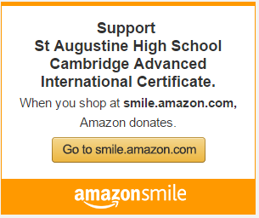

Help raise funds for AICE while shopping at Amazon.

- Amazon donates 0.5% of the price of your eligible AmazonSmile purchases to the charitable organization of your choice.
- AmazonSmile is the same Amazon you know. Same products, same prices, same service.
- Support your charitable organization by starting your shopping at smile.amazon.com

On your first visit to AmazonSmile (smile.amazon.com), you need to select a charitable organization to receive donations from eligible purchases before you begin shopping. Your selection will be remembered and then every eligible purchase you make at smile.amazon.com will result in a donation.

Search for St Augustine High School Cambridge Advanced International Certificate to select AICE as your charity. Additionally, you can use this direct link https://smile.amazon.com/ch/35-2511434 or go to the school’s AICE website (http://www-sahs.stjohns.k12.fl.us/aice/), scroll down till you see the above banner and click on it.

Help raise funds for AICE while shopping at Amazon.

- Amazon donates 0.5% of the price of your eligible AmazonSmile purchases to the charitable organization of your choice.
- AmazonSmile is the same Amazon you know. Same products, same prices, same service.
- Support your charitable organization by starting your shopping at smile.amazon.com

On your first visit to AmazonSmile (smile.amazon.com), you need to select a charitable organization to receive donations from eligible purchases before you begin shopping. Your selection will be remembered and then every eligible purchase you make at smile.amazon.com will result in a donation.

Search for St Augustine High School Cambridge Advanced International Certificate to select AICE as your charity. Additionally, you can use this direct link https://smile.amazon.com/ch/35-2511434 or go to the school’s AICE website (http://www-sahs.stjohns.k12.fl.us/aice/), scroll down till you see the above banner and click on it.

