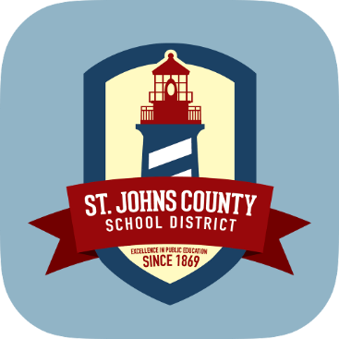
St. Johns County School District Transportation Department __________________________________
Become a School Bus Driver
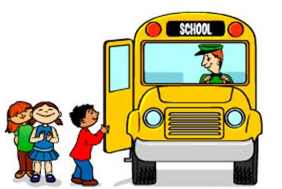
Make a difference every day!

*$500 sign-on bonus for newly referred drivers
*$500 bonus for referring SJCSD employee
(Conditions apply, call for details)

©Lakeshore
New Drivers:
- We will pay you to train for your CDL Class B licensing with the Passenger and School Bus endorsements
Compensation:
- Pay scale based on experience: $13-21.00/hr
- Hiring full and part time drivers for daily routes, field trips, and weekends
- 180 work days & 6 paid holidays
Benefits:
- St. Johns County School District Benefits Package includes medical, dental, and vision coverage, and much more
- Enrollment in the Florida Retirement System
Contact Rebecca D’Alessio for more information:

P: (904) 547-8814
E: Rebecca.Dalessio@stjohns.k12.fl.us
Requirements:
- Licensed driver for the past 5 consecutive years
- No DUI/Reckless Driving charges
- Background check
- Drug screen
OVER
- Physical
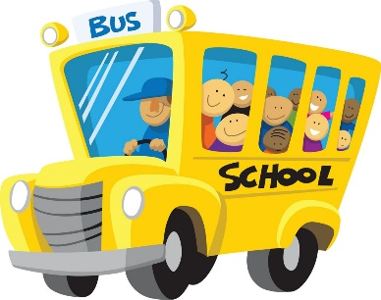

Thank you for your interest in becoming a Bus Operator. The first step of the recruitment process is to fill out an online application. Please visit the St Johns County School District homepage at: www.stjohns.k12.fl.us.

- Select the JOB SEEKERS tab at the top
- Select the AppliTrack box on the right
- Select Substitute Bus Operator (Driver) on the left
- Click red Apply box on the right

The online application process will take approximately 30-60 minutes to complete. In Section 4 of the application, Vacancy Desired, make sure the JobID 5523 (Substitute Bus Operator) box is checked. In Section 5, Position Desired, “Transportation” is listed. Do NOT check this box. Leave it blank. These instructions are to ensure that you are applying for the correct job opening and that your application will be seen by the Transportation Department.

*PLEASE NOTE* Pay extra attention to the security questions regarding background screening. To be considered for employment with the St Johns County School District you must successfully pass a high-level background check. The information provided in your online application MUST correspond with the results of your background check. Be sure to disclose ANY infractions, no matter how minor or long ago they may have been. A record of an infraction may not disqualify you for consideration. Failure to disclose an incident in your application, however, is reason for an employment offer to be withdrawn.

After you submit your application please call (904) 547-8814 or email Rebecca.Dalessio@stjohns.k12.fl.us stating that your application is complete. If you require assistance filling out an online application please call to make an appointment. We look forward to speaking with you further!

PS: Check out our video! http://www.stjohns.k12.fl.us/transportation/2018/12/20/now-hiring-bus-operators/

OVER

